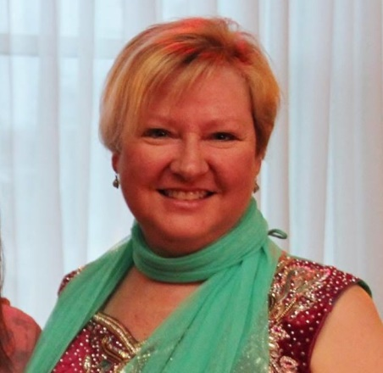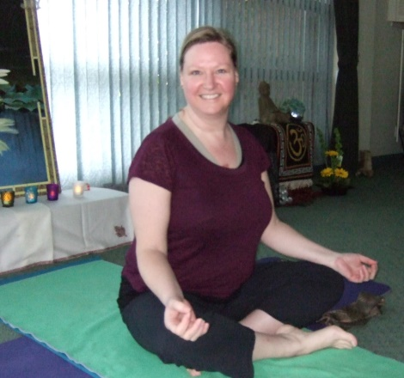
PATRICIA PARSONS, co-owner Healing Movements Yoga Centre
After many years of life in a stress filled corporate world, Pat made a conscious shift towards yoga which helped ground her in dealing with stress and anxiety. As well as the added health benefit of pain relief from years of suffering with scoliosis and arthritis.
After completing her 500RYT through South Okanagan Yoga Academy (SOYA), she founded and created “Parmi Plus Yoga”, one of the first plus size yoga programs in Canada and leads teacher training programs and workshops across Canada. As co-owner of Healing Movements Yoga Centre, Pat went on to Study under Amy Weintraub in Tucson, Arizona in 2015 allowing her to further work Yoga for Depression and Anxiety into her teachings. Pat is a great advocate and truly believes yoga is for everyone, no matter what mobility issues may surface (physical, emotional or mental). Pat's classes are gentle and meditative with attention given to inner awareness.
Drawing on her love of teaching from many inspirational leaders and gurus she has had the privilege of studying with. Teachers such as Marion (Mugs) McConnell, Chris Clancy, Amy Weintraub, Sri Dharma Mittra, Rod Stryker, Erich Schiffmann, Trudy Austin, Leslie Howard and Dr. Swami Satya Prakash to name a few. Pat specializes in yoga for depression and anxiety (Mood management), Plus size yoga (body modifications) and Yoga for the Female Pelvic Floor.

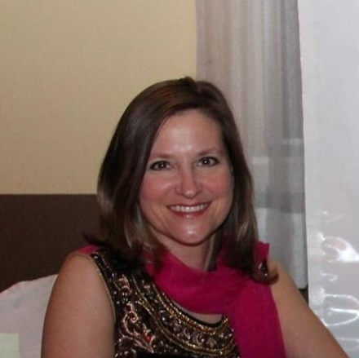
JODY MISAK, co-owner Healing Movements Yoga Centre
Jody is a compassionate, experienced yoga instructor committed to make a difference on and off the mat.
As co-owner of Healing Movements Yoga Centre, Jody is a dedicated teacher and student of yoga and a strong advocate of yoga’s trans-formative powers. She passionately shares the healing benefits of yoga, through breath work, mindfulness movement, and other traditional yoga techniques that work towards achieving self-awareness and self-regulation.
An 800 hour Vijnana International Yoga instructor, Jody looks to bring an ease of fluidity and awareness for her students and into her yoga classes by providing a supportive, non-judgmental environment.
Jody is a certified 500 ERYT with Yoga Alliance and 800hr from Vijnana International and has served with Yoga Outreach teaching trauma informed yoga in a women’s prison. She has trained in restorative yoga, pre-natal yoga, yoga for kids, and The Tensegrity Repair Series and draws her inspiration from many teachers and Gurus. Teachers such as Marion (Mugs) McConnell, Dorothy Fizzel, Chris Clancy, Gioia Irwin, Orit San Gupta, Sri Dharma Mittra, Rod Stryker, Erich Schiffmann, Trudy Austin, Leslie Howard and Dr. Swami Satya Prakash to name a few. Jody specializes in Vijnana Yoga, The Tensegrity Repair Series and Trauma informed Yoga.

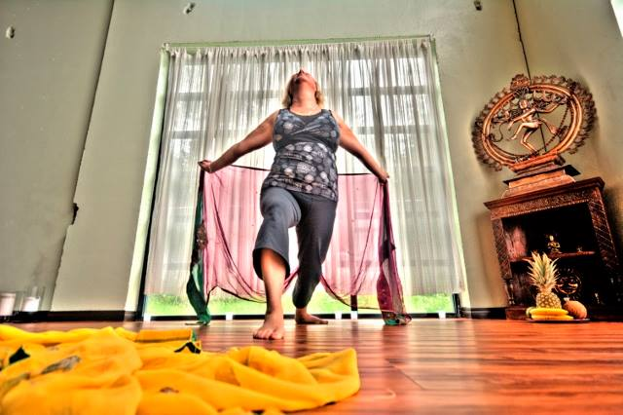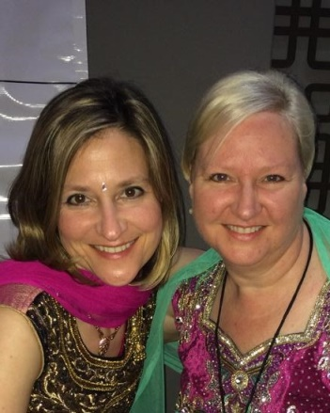
YOGA TO MANAGE YOUR MOOD
with Patricia Parsons and Jody Misak
Mental illness indirectly affects all of us at one point or another, either through our own personal experience, a family member or perhaps a friend.
In this workshop we will explore traditional Yoga techniques in breathing, easy postures and guided meditations to help in managing your mood and give an overall sense of wellbeing.
We will learn:
- Pranayama (breathing techniques) that help regulate the emotions
- Creating positive Intentions to foster self esteem
- Gentle Asana (guided postures) to clear energy that may be stuck
- How to effectively use mantras (chanting sound, word or phrases)
- Meditation to clear Chakras (energy channels) for optimal wellness
- Yoga Nidra to calm and help cool the nervous system
- To centre and balance
In our day to day lives we have many rolls and finding balance can be difficult. Reaching balance is a learning process, but good mental health is within everyone’s grasp.
This workshop is available to all levels and no yoga experience is necessary.

